Glo’More Microblading and Beauty Academy
Academic Catalog for Eyelash Extension

“Glo’More Microblading and Beauty Academy is approved to operate by the Private Business and Vocational Schools Division of the Illinois Board of Higher Education (EBHE) and is not accredited by a US Department of Education recognized accrediting body.”

Mink Eyelash Extensions Training

Mission Statement

Our goal is to teach students the art of creating semi-permanent microblading eyebrows, permanent cosmetics and eyelash extensions classes with written theory education and hands-on practical using mannequins and live models. Our mission is to attract students who are passionate about the beauty industry and confident in enhancing the appearance of customers by applying their new skills. With proper training, our graduates will be able to receive a lucrative pay for accurately performing these highly requested services.
WHAT YOU'LL LEARN:​
​Description and Objective: This program prepares students to apply synthetic mink lashes to the natural eyelashes of customers. Training Includes: the history and current information of eyelash extensions, client/patient evaluation and care, eye health and disorders, sanitation and infection control, eyelash length and different styles, before and after pictures of Glo’More clients, list of supplies needed to perform procedure, basic and advanced step-by-step eyelash application, eyelash touch-ups and removal instructions, applicable laws and regulations, and business practices. Eyelash extensions procedures are currently in high demand and will last 8 to 12 weeks with proper 2-4 weeks touch ups. It allows customers to avoid the daily hassle of applying temporary eyelash extensions to enhance their appearance.
Admission Requirements: All students must be 18 years old or older and have completed High School or GED. The Illinois Department of Financial and Professional Regulations (IDFPR) http://ilga.gov requires students who are interested in becoming an eyelash extensions technician, must first be a licensed cosmetologist, esthetician, nail technician, or hair braider.
Eyelash Extensions Training are designed to fit student’s unique schedule when needed and are offered bi-monthly. When scheduled, Glo’More requires six hours of theory on day-1 and six hours of hands-on practical on day-2 for a total of 12 hours of training. Students who have successfully completed the basic and advanced training are free to attend one future basic class if needed.
​Financing available through Gurnee Community Bank
​“Every Day Loan” Contact Person: Isela Rios (847)-367-4726

PROGRAM INFORMATION (Tuition and Fees must be prepaid one week before class begins and a detailed description is located on website at www.glomore.com):

Mink Eyelash Extension Classes
Learn the latest techniques in Basic and Advanced Eyelash Extensions Application. Class includes 12-hours of training and minimum class supplies only. Kits will be provided.
​Saturday & Sunday from 12 Noon - 6:00pm
Must bring model to Second Day of Class.
​CLASS SCHEDULE:
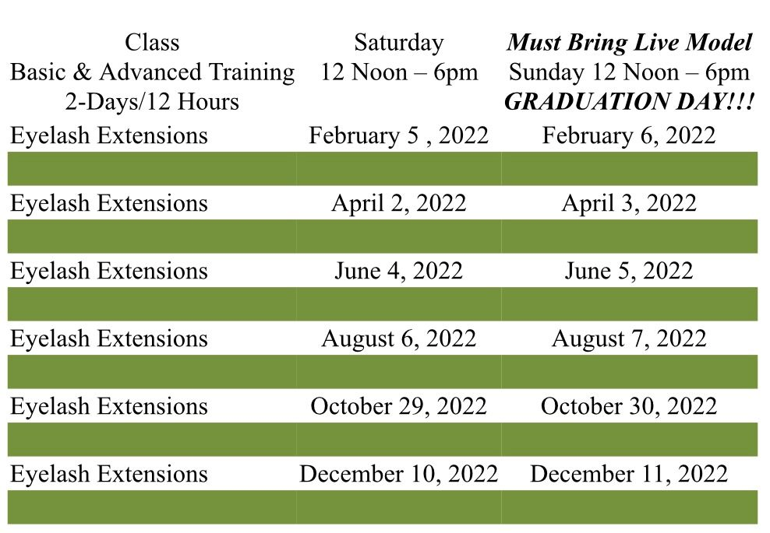

A $300 deposit most be paid to reserve seat and the balance of $550 must be prepaid one week prior to start of class.

CANCELLATION AND REFUND:
(Please Initial complete understanding of our Policy)

Students will have three days to request a refund of the paid deposit. Afterwards, the $300 deposit is non-refundable. After the commencement of class and the full tuition is prepaid, if student needs to cancel their attendance for any reason, Glo’More has the right to reschedule the student’s attendance to future classes at an additional fee of $100. If 50% or more of the training is completed by the student, there will be NO REFUNDS ALLOWED.

Graduates are welcome to sit in future classes for reinforced training at no additional charge with the approval of Glo’More.

100% Attendance is required and if student doesn’t meet this requirement, NO REFUNDS WILL BE ALLOWED AND NO CERTIFICATE WILL BE GIVEN.

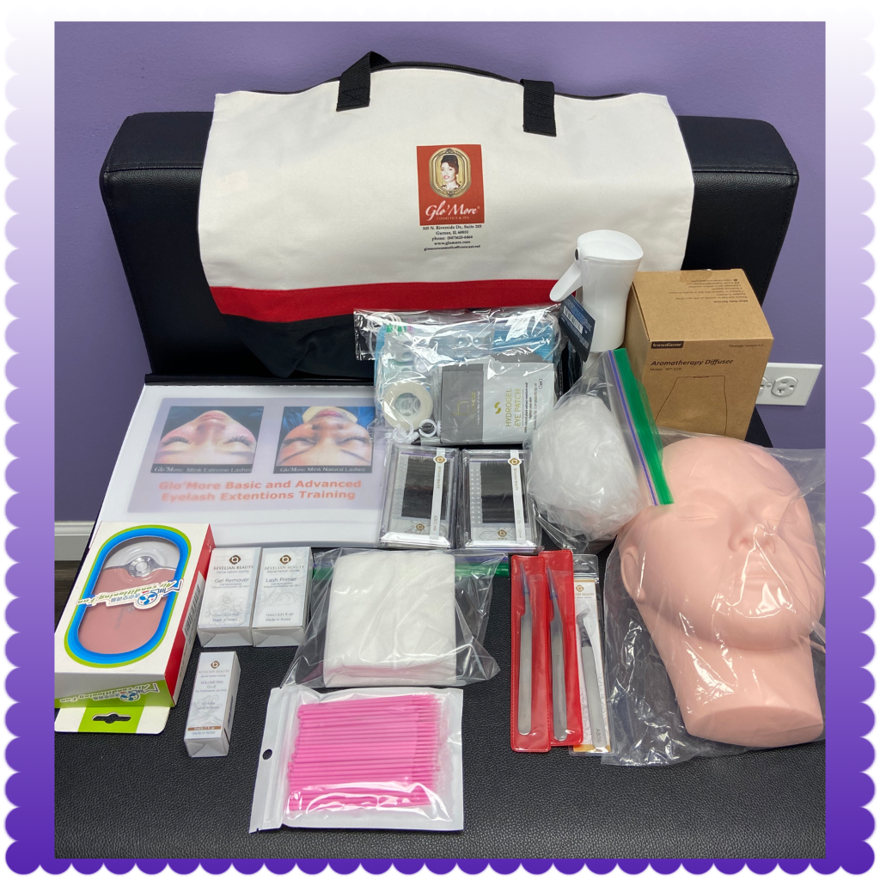

NOTICE TO STUDENT:
(Please Initial complete understanding of our Policy)

Do not sign this agreement before you have completely read it and checked or initialed understanding of our policy.

Upon signing and dating this enrollment agreement, it becomes legally binding. A copy of the agreement will be given to the student upon completion.

Glo’More does not transfer credits of coursework to another school, college, or university. Nor does Glo’More accept credits from previous schools, training facility or work experience to be applied towards training.

Glo’More does not guarantee job placement to graduates upon program/course completion or graduation.

Glo’More reserves the right to reschedule training start date if and when necessary.

Glo’More reserves the right to discontinue training to students for nonpayment of tuition, failure to abide by academy rules, or unsatisfactory progress by student.

I understand that complaints, which cannot be resolved by direct negotiation with the academy in accordance to its written grievance policy, may be filed with the Illinois Board of Higher Education (IBHE) located at: 1 North Old State Capital Plaza, Suite 333, Springfield, IL 62701 or at www.ibhe.org (217) -782-2551.

